Dear Friends
In honour of the life and recent death of Nelson Mandela, this newsletter has been compiled by members of ARROW SA, Indra’s partners in South Africa. Many thanks to Mary Lange for co-ordinating the newsletter. There is also a section from Urvashi Sahni in India with the latest news on her excellent initiative, India’s daughters, Unwanted, Unsafe, Unequal. Urvashi and I have been discussing ways in which the Indra Congress can support this urgently needed campaign.
I would like to thank the friends and colleagues who have given me such encouragement and support over recent months. In the Autumn of last year I was diagnosed with cancer on my vocal cords. There followed a period of ordeal by radiotherapy, which was unpleasant and draining. However, helped by the dedicated skill of staff at Derriford (Plymouth) Hospital and the love and support of family and friends I have emerged back into the light of day! My latest assessment shows no sign of the cancer and I am looking forward to a full recovery.
David
Indra newsletter
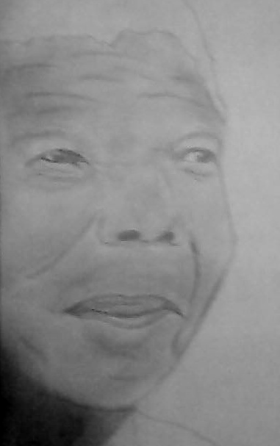

From South Africa
There are many that can inspire people, groups or artists,
but not many
that can continue to inspire generation after generation
Tata Madiba, the father of our nation,
may you rest peacefully.
Our country has lost a Hero
the world has lost an icon
but heaven has gained an angel...

Poem and drawing by Darnell Fortune, ARROWSA Bechet Indra, Dec 2013.

In this Indra newsletter we’d like to thank all the Indra groups and individuals who sent their condolences and wishes to us and South Africa on the passing of Nelson Rolihlahla Mandela (also known as Madiba, his clan name, as a sign of respect). We’d also like to share a snippet of South African’s words and reactions to Madiba’s life and passing that are from people that we know. This is further in response to the wonderful letter that Indra Bolton UK youth sent to us where they shared their respect for Madiba and condolences to all of us.
We thought the passing of Nelson Mandela would be an important time to make contact. How does it feel in South Africa at the moment? How has it affected the whole of South Africa and how does it feel personally? …I don’t personally know Nelson Mandela but what I do know is that he is a significant role model to many people around the world and we love him.

When the news of Nelson Rolihlahla Mandela’s passing was officially announced many mourned, reflected and pledged not to forget. There were some who were cynical about the timing of his passing and others who misused the nation’s loss for political punting. The governing party was embarrassed and shown wanting at some of the public memorial events. What is, however, mostly appreciated is the fact that we presently live in a country where the ruling party can be criticised by media and individuals, which is in sharp contrast to the apartheid years, and is largely as a result of Madiba’s stand. The violence that some predicted would transpire with the passing of South Africa’s peace champion and first democratic president did not happen. Thousands from all cultures, creeds and races peacefully paid respects to Madiba whether outside his residences, in their homes or at memorial services.

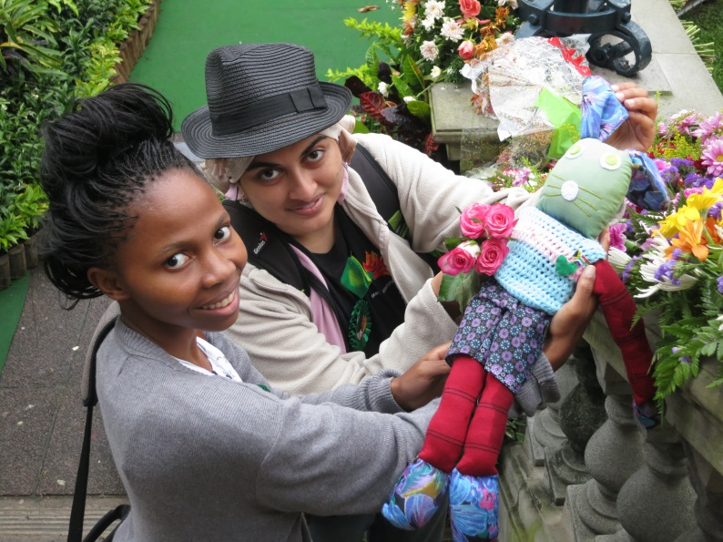
“When a great soul leaves even the clouds grieve. Crowds gathered on Durban’s town square to pay tribute to the Son of the Soil, Nelson Mandela. Field journalist Khatija Nxedlana (left) and Sanabelle Ebrahim were amongst the crowds witnessing Madiba’s memorial service relayed on an outside screen at City Hall Durban from the FNB Stadium in Johannesburg on Tuesday 10 December.” Sana Ebrahim, Photo: Mikhail Peppas

Archbishop Emeritus Desmond Tutu gave a moving tribute to Madiba at St George’s Cathedral in Cape Town, Dec 6:
One gift that you and I can give to the world as a fitting memorial, remembrance of Tata is for us to become what the world had thought impossible…God, thank you for the gift of Madiba. Thank you for what he has enabled us to know we can become. Help us to become that kind of nation.

A Durban youth, Sandrini Moodley, who has a photo of Madiba holding her as a baby, expressed her thoughts on him in song (https://m.facebook.com/SandriniM/posts/644717188901081):
In prison he stayed for 27 yrs
They tried to break his spirit
Take away his pride
But nothing could defeat
The love he had inside
He fought so hard
For what he believed
And now the people
Of his nation say
Madiba we love you
From the bottom
Of our heart
The treasure of our country
a hero and an inspiration
we the people
salute you

Madiba’s indomitable spirit is echoed by one of the Indra Bolton youth:

The man was graceful and forgiving. He never gave in to the cruel soul crushing world around him. His mind was never broken, never straying from his rightful true path. If someone can forgive all the hate, all the cruelty and prejudice aimed towards him and many others, then hope will never be lost. He will be in our minds and hearts forever.

Locally many reflected on personal memories that they were fortunate enough to have, of meeting Madiba. Kathy Burger, who has hosted many ARROWSA Bechet Indra trips to the Kalahari, said:
Everyone spoke of Mandela’s love for children until it almost became a cliché. But, when mom and dad gave him the porcelain doll named after his daughter Zindzi, he of his own accord bent down and firstly picked up Amelia and then bent down and spoke to Jannie. He needn’t have done that as they weren’t forced on him. But he genuinely cared for children.
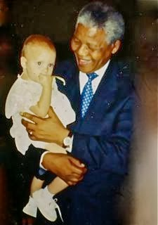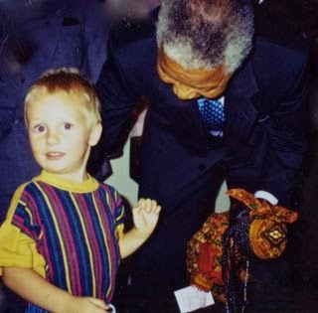
Photo: B. Fisher
The impact that Madiba had internationally was appreciated by Kholeka Zikhale (ARROWSA Bechet Indra participant) and Bheki Dlamini (ARROWSA Bechet Indra leader) when they visited his statue in London after the Indra Derry congress in 2013. There were letters and flowers at the statue which expressed wishes for his health and recovery. Kholeka and Bheki expressed surprise that our leader was so respected in London and even felt that more appreciation was shown to him in the UK than was in South Africa at that time.
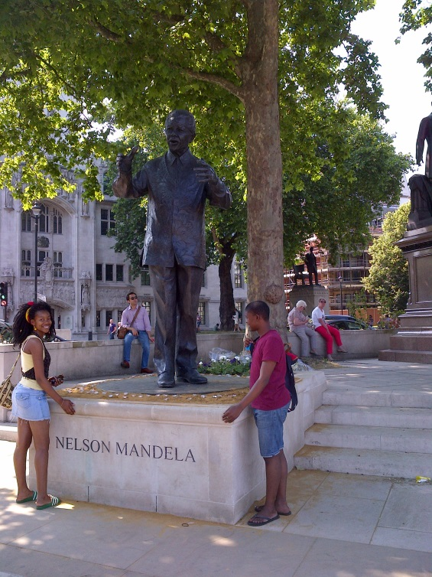 Kholeka and Bheki in London 2013. Photo: M. Lange
ARROWSA has strived, and continues to strive to keep Madiba’s legacy alive as he promoted principles echoed by ARROW and now Indra:
What counts in life is not the mere fact that we have lived. It is what difference we have made to the lives of others that will determine the significance of the life we lead. Nelson Mandela
Madiba himself confirmed his appreciation of the power of the arts when on stage with South African singer and activist, Johnny Clegg, he said: “Music and dancing makes me at peace with the world and with myself.”
In 2009 the ARROWSA youth Londiwe Vilakazi, Keran Fynn and Sertanya Reddy expressed their appreciation of Madiba in a letter to him for the same birthday. They shared with him how they were using the arts to continue the important work that he started:
…without you we wouldn’t be where we are today – living together as one people in our beautiful country, South Africa… multi-racial ARROW (Art: A Resource for Reconciliation Over the World) South Africa group of Bechet Secondary School in Sydenham, Durban, spent time working on a play called “The Bridge” (by Jeton Neziraj). It is a play about a rural and urban community who are separated by a bridge made of jewels. It is only when the two communities work together to overcome their differences for the betterment of society, that they are able to live in peace and harmony.
Thank you for being the first to build a “bridge” for South Africans – we hope to continue the work you have started.
The magnitude of Madiba’s death and the task ahead for all of us was summed up by Prof Ruth Teer-Tomaselli of The Centre for Culture, Communication and Media Studies, University of KwaZulu-Natal, an affiliate of ARROWSA:
This has to be an exceptional day. The whole country shuts down in honour of a most honourable man. Less than two weeks before Christmas, many chain stores closed their doors to mark the solemnity of the occasion. Let's hope the importance of the lesson stays with us.
ARROWSA commits with Indra international to continue to promote Nelson Rolihlahla Mandela’s legacy:
Nelson Mandela was a truly inspirational man, to get straight to the point. He stood up for what was right, and that’s awesome and so brave. I probably wouldn’t have been able to do that, but I’m so glad Nelson Mandela did, because he changed the world for the better – and doesn’t everyone wish to do that one day?.Indra Bolton UK.

A message from Dr Urvashi Sahni, Founder and Director of the Study Hall Education Foundation and Indra Congress partner, Uttar Pradesh, India.
India’s daughters: Unwanted, Unsafe, Unequal
There are 10 million child brides in the world and 1/3rd of those are in India! Child marriage is one of the greatest threats to a girl’s life and liberty. We should stop euphemising its horror and sanctifying it by calling it "marriage". We should call it 'girl slavery' which far more appropriately describes what child marriage does. It enslaves a girl physically, sexually, psychologically and emotionally, and does her enormous harm. Her education is truncated, her immature body is weakened and rendered ill by early and repeated child birth. Young and afraid, she is unable to offer any resistance to oppressive and abusive in-laws and husband. Even before she embarks upon it, she loses all control over her life! Even though the Indian legal system outlaws the marriage of a girl before the age of 18, society (especially in rural areas) not only sanctions it, but actively promotes and encourages it by creating peer pressure to marry off girls young.
Many people maintain that they are under tremendous pressure by society to marry their girls as soon after they reach puberty. Marrying girls young is perceived as a way of settling them, keeping them safe, chaste and in control. Social norms in India do not allow girls to be autonomous, equal persons with the right to live life to its full potential. We at SHEF (Study Hall Education Foundation) have been working for girls' right to live as equal, autonomous persons worthy of respect for several years through our own schools and in 48 Kasturba Gandhi Vidyalayas in UP. This year we are campaigning specifically against child marriage in all 48 KGBVs, in partnership with all 4800 families of the students of the KGBVs and all 48 communities where the KGBVs are located. We begin SHEF’s initiative with our India’s Daughters Campaign; we invite you to join us in our fight against child marriage in India. We look forward to receiving your blogs, messages and entries of any kind to encourage and inspire our students and their parents to say NO TO CHILD MARRIAGE/GIRL SLAVERY! Thank you!
More information about Study Hall and the India’s Daughters Campaign can be found at www.studyhallfoundation.org

