Draft Newsletter 8
Dear Friends of Indra
This newsletter is written in celebration of the wonderful Congress in Derry organised by Mary Duddy and Sinead Devine. The Congress was set alight by the creative energy, joy and friendship of the committed young participants who travelled from Palestine, India, South Africa, Brazil, Greece, Cyprus and from Burnley, Bolton, Durham and Plymouth in the UK. The event was an inspiration to us all.
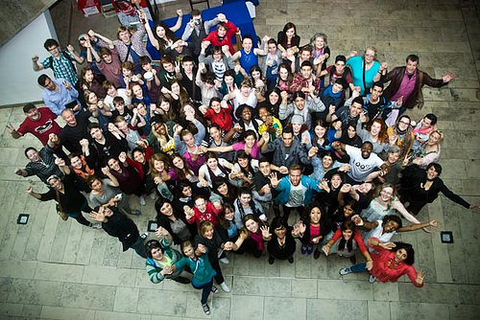
Photo: Emmett McSheffrey
Emmett was the official photographer for the event and you can view a selection of his Congress images, This is Indra 2013, on youtube at:
http://www.youtube.com/watch?v=6Vn3ZSjxs1A
The photographs are accompanied by the Congress song, Happy Accidents, written, recorded and performed in less than a week by participants, with the guidance of singer/song writer Paddy Nash.
The successful hosting of the Congress represents a huge achievement for Mary Duddy and the members of First Act Theatre. For our last ARROW/Indra Congress we enjoyed the backing of a University College, the use of space and accompanying infrastructural support. Mary undertook the task this year as an isolated practitioner running a small youth theatre with minimal resources. It was a great idea to link the Congress with the celebrations for the Derry City of Culture 2013 as this enabled Mary, with the help of the irreplaceable Sinead Devine, to engage with the City and attract support from a range of sources. So, many thanks to UK City of Culture Company, EU Regional Development Fund under the PEACE III Programme, Arts Council NI Lottery funding, The Anna Lindh Foundation, Derry City Council Good Relations Project Funding, the University of Plymouth and local businesses Quinns Garage Ardmore and Centra, Trench Road and Mr and Mrs Grace.
Congress participants had to fund their own journeys to Derry, as there was no central pot of money to draw on. This in itself presented huge fund raising challenges for young people and co-ordinators and the demand was met though a variety of local fund raising events and activities – First Act raised the resources to sponsor one of the Indian girls for example, and the generosity of sponsors, families and friends made the event possible.
Disappointment
It is always disappointing and sad when potential participants are unable to attend these events. For example, it was a shame that we had no representation this year from Kosovo or Sierra Leone. It is doubly sad when fund raising efforts have been successful and participants are so much looking forward to the Congress as a major experience, only to be turned down by the dead hand of bureaucracy. During the week our hearts went out to Shweta, Preeti and Tulsi who were due to be part of the Indian group. They had their visa requests turned down by the British High Commission. A deeply upset Dr Urvashi Sahni, Head of the Study Hall Schools Foundation and their teacher, explained that all the girls had exactly the same paperwork and that she was nonplussed as to why 2 had been approved and 3 rejected. These courageous young women fight daily all the prejudices in the book from sexism to caste-ism and they were heartbroken at missing out on this life transforming opportunity. We wish them well and I hope we can keep in touch with them and bring them to another Indra event.
What happened at the Congress?
During the week we were treated to a running series of presentations, which represented the wide range of practice within the Indra groups. The performances were moving, and sometimes painfully challenging, but they were all characterised by a strong sense of hope.
From Greece we watched a powerful and disturbing film, which showed the despair experienced by too many young people as they cope with an ugly growth of bullying in their struggling society.
The young people from Bolton demonstrated through presentation and film the range, depth and quality of their activities in the town; an impressive diversity of projects and workshops generating ideas and practice that challenge prejudice, alienation and racism.
From Cyprus we were treated to a ritualised performance, rooted in images of mythology and classical drama that portrayed the struggles of the past and present on the island, but which showed a strong hope for the future.
Although the Indian group was depleted by the absence of their three colleagues, they produced a very moving presentation using drama, dance and film, which showed the struggles of young women to resist forced, early marriage and to fight for their rights to education, respect and equality. Despite the loss of three out of the five actors the performance was a very special event. At the 2010 ARROW Congress the Indian girls had made a presentation which told the story of their friend Khushboo who had been forbidden to attend the Congress because her father had insisted she discontinue her education and accept early marriage. This year Khushboo herself was present at the Congress and Dr Sahni showed the award winning short film in which Khushboo featured.
From Palestine we watched a strong, intense piece of theatre depicting the harrowing experiences of young people under Occupation, the brutal restrictions to travel in and out of their own land and the extraordinary challenges they face in their daily lives. The play was an adaptation of a chapter in Mourid Bargouthi’s novel, The Bridge. In Bargouthi’s words: ‘The cliché has it that bridges are symbols of communication, connection and coexistence. This bridge is a symbol of discrimination, distance, disunion, and the historic distinction between the frightener and the frightened, though sometimes it is hard to be sure who fears the other more.’ Despite the stark reality of the situation the young people were amazing in their positive attitudes and the hope they communicated.
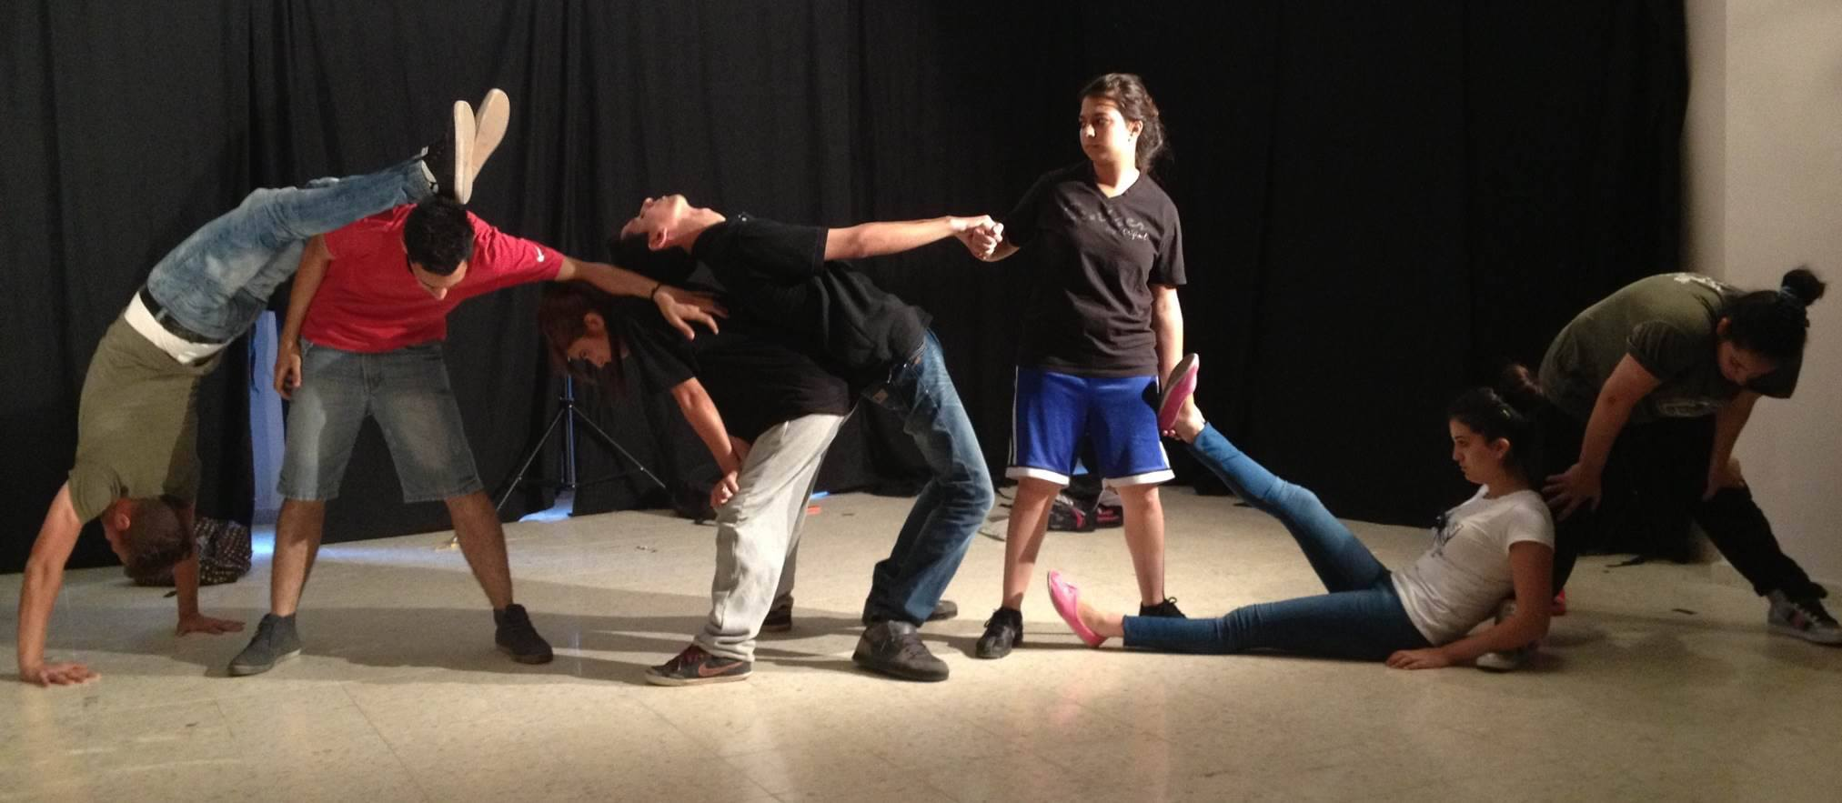
Photo: Myrna Sakhleh
The group from Durham is part of the wider Jackass Youth Theatre and they treated us to an extract from their sobering, moving yet humorous play, Get Along, based on the village Categorisation scheme that was implemented by Durham County Council in the 1950s - Villages were graded A-D; A being economically viable and therefore worthy of support and regeneration, D being classed as a dying community after the closures of many mines and cokeworks. These villages were left to ruin, with councils buying up houses in streets and leaving them to decay, destroying the village aesthetic and driving out other inhabitants.
The Burnley group entertained us with a playful, ingenious exploration of the impact of football on the lives of young people in the town and the array of behaviours and attitudes from passion to hooliganism that emerge from it.
The South African group presented an informative and insightful presentation into the diverse cultures, traditions and tensions in their country, which is struggling to forge a new identity for itself. The presentation provided a platform for the talents and verbal skills of the group and identified many questions and troubling issues facing young people.
The Plymouth group treated us to a powerful, moving and excitingly theatrical portrayal of the confusion and anxieties faced by young people in the UK as they struggle with the expectations and demands of the pressure cooker of education and their search for authentic identity.
And lastly, our very own hosts, the young people of First Act Theatre in Derry gave us a rich, diverse presentation, part spoken, part drama and part film which showed the very real, authentic strides that have been made in Northern Ireland towards a more peaceful future. The presentation was bravely honest about the underlying tensions that still exist in the community, but was very positive about the extraordinary achievements that have been made and the hope that is emerging after so many years of despair. The group lifted the Congress with their presentation and their warm, caring hosting of the entire week.
The Artists
During the week the participants took part in an exciting range of art workshops, which culminated in a joyous celebratory performance and exhibition evening at the Millenium Centre. Mary Duddy led the team of artists and under her leadership the drama group produced a rich and vivid piece of theatre expressing their frustrations, feelings and aspirations.
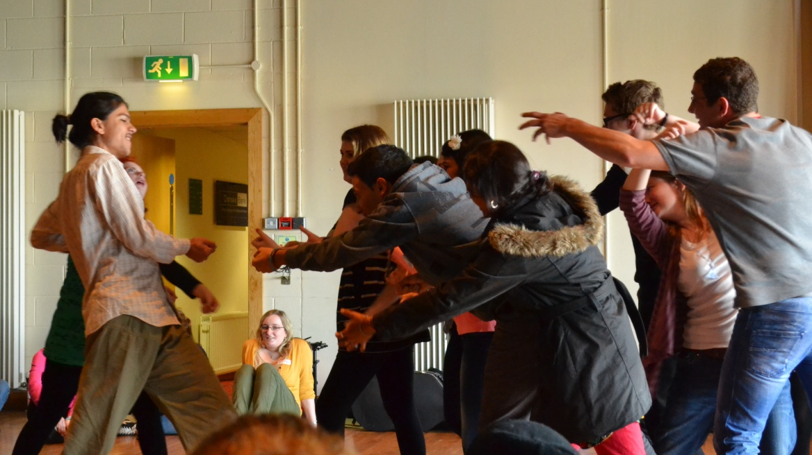
Photo: Alix Harris
Visual artist Trisha McNally worked with the participants to produce a series of Indra nets; each participant at the Congress designed and made their own pearl with their individual choice of imagery, decoration or words. The whole net was quite amazing. Meanwhile, in the dance studio, Janie Doherty of Echo Echo Dance Theatre Company skilfully created a web of movement that allowed space for a rich and diverse array of expression.
Singer/song writer Paddy Nash worked with the participants to devise, write, rehearse and perform a very moving song for the Congress, Happy Accidents, which will be wormed into our heads for a long time!
Digital photographer Emmett McSheffrey, working in meticulous detail, took individual portraits of the participants, which were then made available for each person to enhance through word, image or reflection.
The Symposium
Tom Maguire, of the University of Ulster, kindly offered us a space for the day-long symposium, which was chaired by Tim Prentki. The day offered an opportunity to reflect on where we are now and where we want to go next. In the morning the delegates of young people and co-ordinators listened to each group’s key principles and aspirations. This was followed by input from the young people who expressed concern about the lack of communication between events, the need to create more linking and partnership projects in between each Congress and for greater engagement in planning. The group from Bolton volunteered to re-vamp the web-site and promote greater opportunities for dialogue and exchange.
The afternoon was spent discussing the practicalities of moving forward. Proposals were made to hold the next Congress for 2015 in Bethlehem, Palestine, followed by South Africa in 2017. These proposals give us clearly defined fixed points around which to build a wider programme of ongoing local, regional and collaborative projects.
Other
The evening of cultural sharing has always been popular with participants and we had a splendid fun evening of dance, music, song and games. On the Thursday afternoon the participants were given a guided tour of the City of Derry walls and visited a couple of museums, which helped to put the week’s experience in a wider historical and cultural framework.
In conclusion .........
A wonderful, transformative week, which will live long in the hearts and minds of those fortunate enough to attend. A striking feature of this Congress has been the groundswell of energy from participants and co-ordinators, which is moving the Indra Congress into new territory. There is much to reflect upon and debate as we move now towards the next Congress in Bethlehem – a significant challenge of planning and organisation in itself.
So, many thanks to Mary Duddy, Sinead Devine, First Act Theatre and the people of Derry, for inviting us to your wonderful city for the Indra Congress 2013.

David Oddie

