Newsletter 7
Derry Congress 2013
An Appeal for support
We are looking forward very much to the Derry Indra Congress, which will take place from June 30th to July 6th as part of the Derry UK City of Culture Celebrations. The Congress will provide an opportunity for our groups of young people from around the world to share their experiences and practice in dealing creatively with conflict in the world around them. During the week they will make presentations, train together, learn from each other and establish relationships and friendships with their peers from diverse and contrasting cultures. Thanks to Mary Duddy’s extensive fund- raising activities a team of artists will facilitate the creation of a giant Indra’s Net and the devising of a collaborative, ambitious and original musical composition.
We know from past experience that these gatherings are transformative experiences in the lives of the participants. As Chistopher Dillon from Derry wrote in the last Newsletter about his experience at the first Congress in 2010: From the moving stories of the Indian girls, to the raw energy and passion of the Brazilians, it was a singular and unforgettable moment in my life; the shining jewel in my life experiences. I have felt more love and friendship in a week, from someone who doesn't even speak the same language as me, than most people will experience in 10 lifetimes! Anyone under its net would be transformed.
Mary Duddy has worked hard to plan and host the Congress and to raise the resources to provide accommodation and meals for the overseas visitors. However, we still need help to support participants with the greatest needs. For example, sponsoring one of Urvashi Sahni’s young women from Lucknow, India, who every day face every prejudice in the book from caste-ism to sexism; our vibrant S. African partners have lost their commercial sponsor and are struggling to raise the travel funds; the Palestinian young people are receiving help from the Anna Lindh Foundation but some of their complex travel costs are still unmet; in Kosovo there is an assumption that now the war is over, the centuries old enmities between Albanian and Serb communities will magically evaporate, so support is withdrawn – whereas NOW is the time for real peacebuilding – a situation also affecting our colleagues in Sierra Leone, one of the poorest countries in the world and still seeking to recover from the brutal war of a decade ago; we have active new groups in Greece and Cyprus who are desperately keen to join us and are working so hard to try to raise resources to get them to Derry. I could go on.
We are therefore asking friends of Indra to help us provide this life changing opportunity for these remarkable young people. Any small contribution would help. If you are aware of any appropriate funding body or foundation that we may not know about, do please contact us. We are determined to make it happen.

Derry Symposium
The Congress will also include a two day Symposium on Thursday 4th and Friday 5th July attended by group co-ordinators, academics and practitioners and generously hosted by the University of Ulster. The Symposium will provide an opportunity to discuss and debate the future of the global Indra network as it moves into the next stage of its development.

On the first day Symposium delegates will integrate with the young people, observe and participate in practical sessions: they will engage with the young people and get a ‘feel’ for the whole process. Day two will offer an opportunity to reflect on the practice and debate issues and implications arising.
The broad title of the Congress this year is: ‘The Art of Cooling Conflict’. During this year some of the groups have been exploring the Cooling Conflict framework, created by John O’Toole and his colleagues in Australia, in their own communities. The framework explores conflict at a micro level, in the school, the playground, the local environment. However, conflict takes place at personal, relational, cultural and structural levels .
Some critics have pointed out the need for our dealings with each other to be ethically consistent at all these levels. We undermine our credibility if we seek to develop community cohesion policies on the one hand and at the same time address international problems, e.g. Iraq, by bombing communities into oblivion.
Using Indra as a reference point, the Symposium will explore how theatre and the arts can support this call for moral consistency at different levels and how these different levels of the personal and the political impact each other.
If you would like to take part in the Symposium do please contact Tim Prentki. We are grateful to Dr Tom Maguire of the University of Ulster, and Dr Matt Jennings who have helped to make the Symposium possible.
The University of Alberta
We are delighted that Diane Conrad and her colleagues in Alberta have successfully gained approval for their proposed international course exploring theatre and issues of global social justice. We are also delighted that they have identified Indra as one of the reference points for the programme. A group of 14 students from Alberta will be attending the Congress and they are in the process of setting up channels of communication with prospective Congress participants.
The Anna Lindh Foundation (ALF) project
Young people in Palestine and N.Ireland
This project is a year- long collaboration between the Indra groups in Beit Jala, Palestine and their peers in Derry, largely funded by the ALF. Both groups have been trained in the core Cooling Conflict idea and are exploring how they can apply the process in their respective communities, share their practice and learn from each other. In January the groups came together for a week’s sharing and training in Derry.
Over the course of the week they undertook intensive training in the Cooling Conflict process; they took part in drama skills workshops, activities relating to personal and cultural identities; they shared performances they are working on in their communities; they participated in cultural sharing activities and learned much about their respective histories and current issues, including a guided tour of the walls of Derry. Historical issues such as ‘settlements’ and ‘internment’ became a focus for dialogue and debate and there were many fascinating resonances. The forthcoming Congress in the summer was discussed and preliminary plans examined.
George from the Palestinian group commented: ‘I discovered this group as a family; I thought people hated Palestinians, but I was amazed how friendly people were to us.’ Jihan echoed these feelings: ‘When I described what had happened to my father and my family I saw tears in people’s eyes. I felt the Irish group really, genuinely wanted to know me.’
The groups set up channels of communication using Facebook for open dialogue and a special page on the First Act web-site for restricted conversations. They divided up into smaller groups of 2 and 3 to enable each person to have a specific ‘buddy’ within the other partner group and committed themselves to a weekly contact: a model that Indra could use with other groups in the build-up to the Congress.
I would like to thank the Quakers of Tavistock, Colin Breed and W.H.Oddie who also supported the Palestinian group in their complicated and arduous journey to get to Derry.
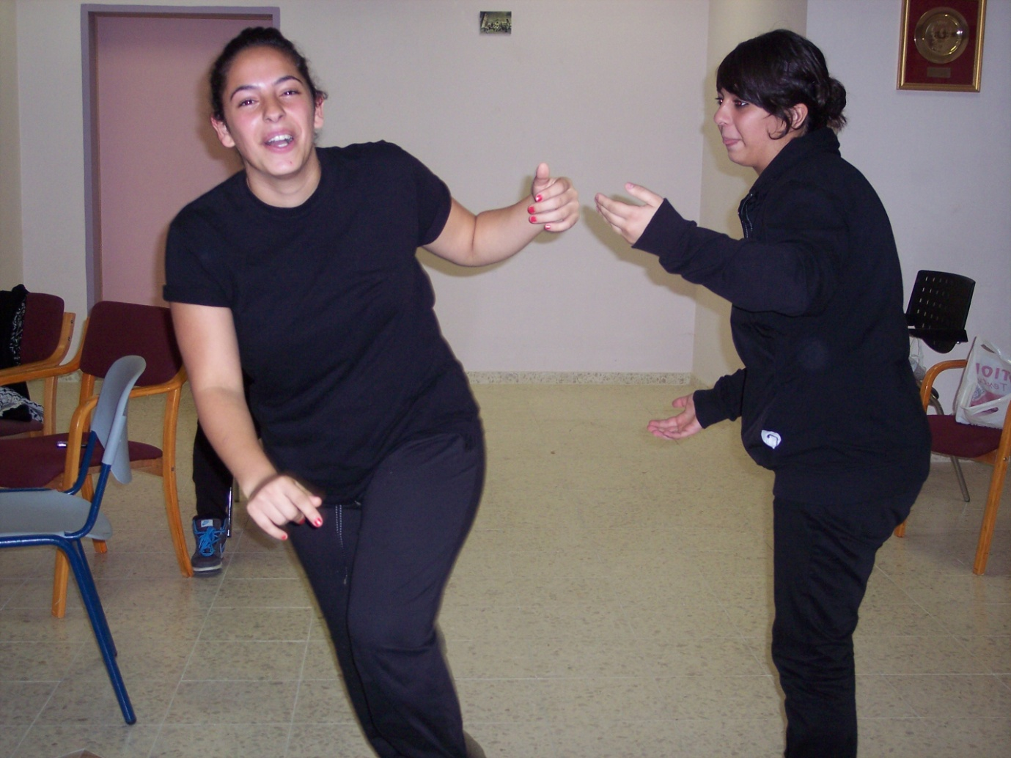

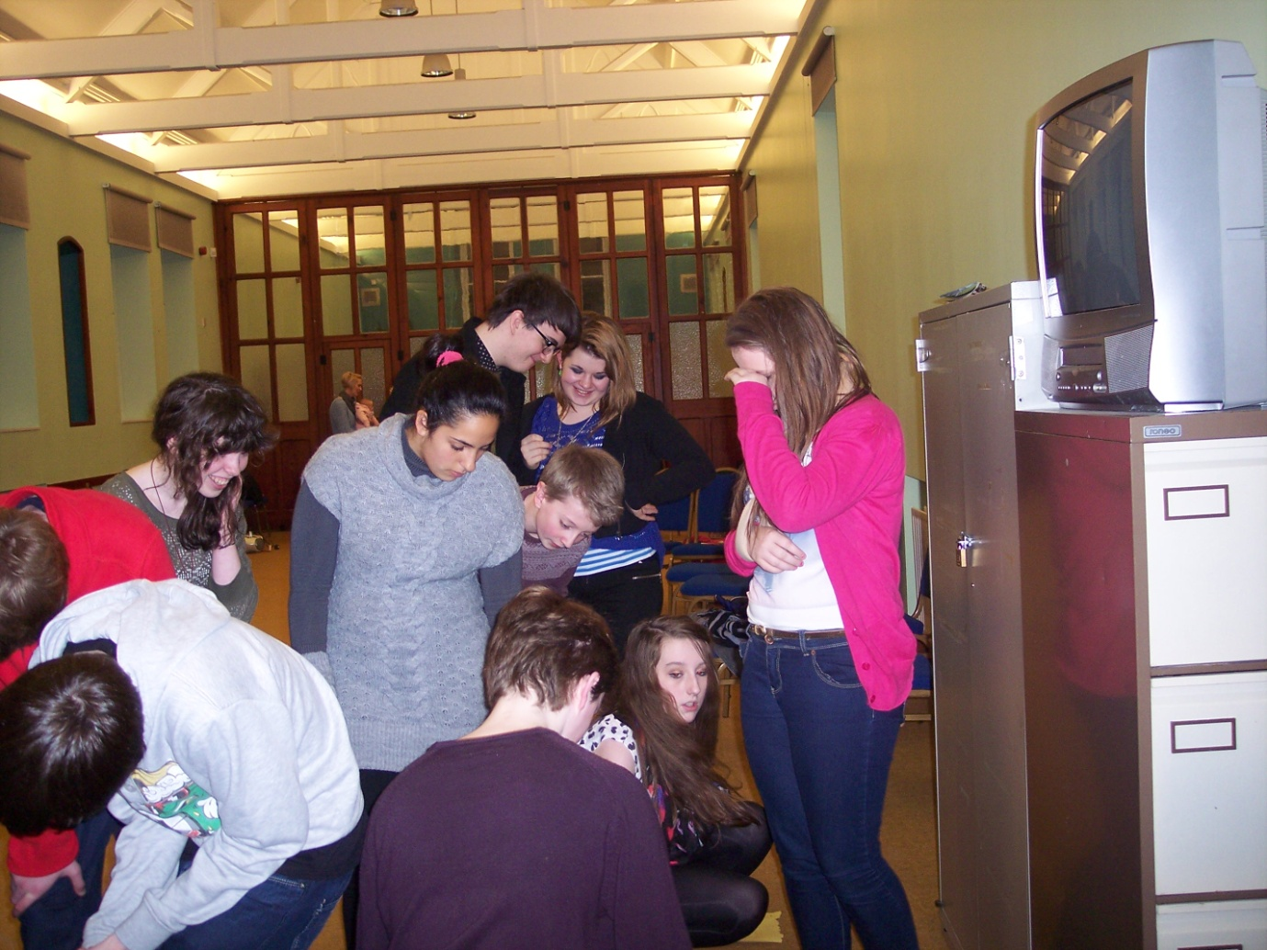

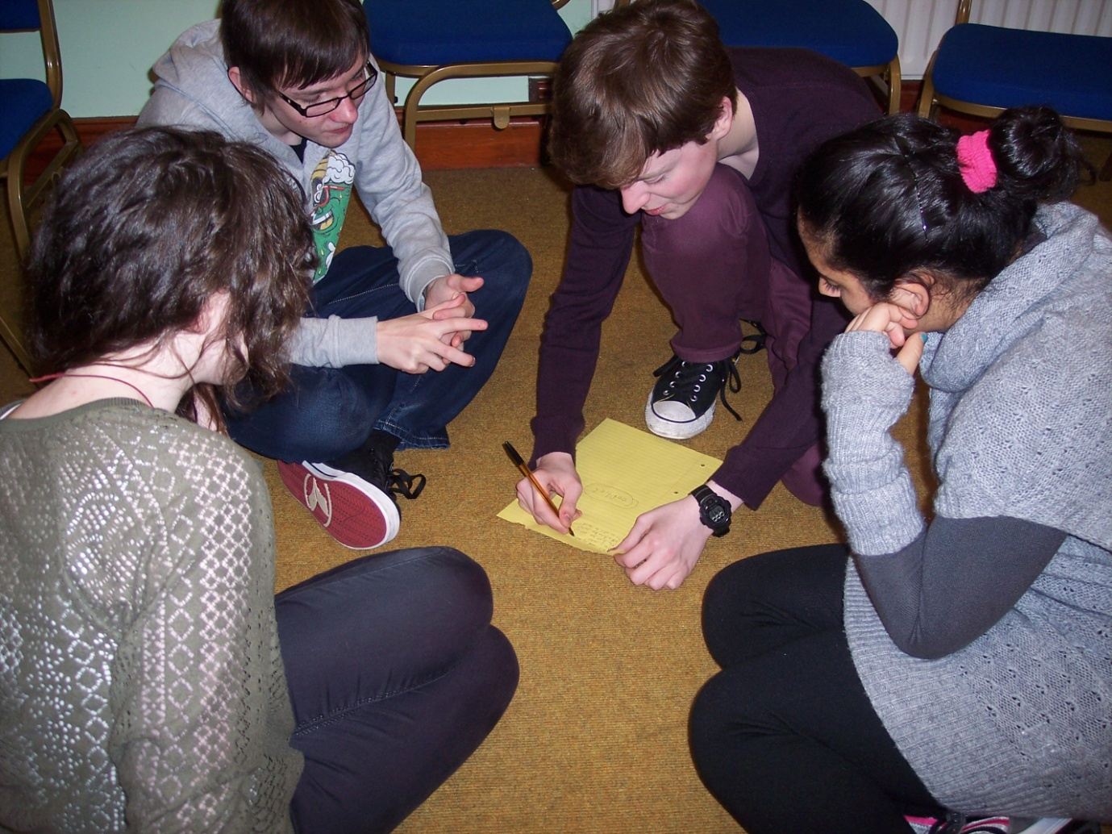

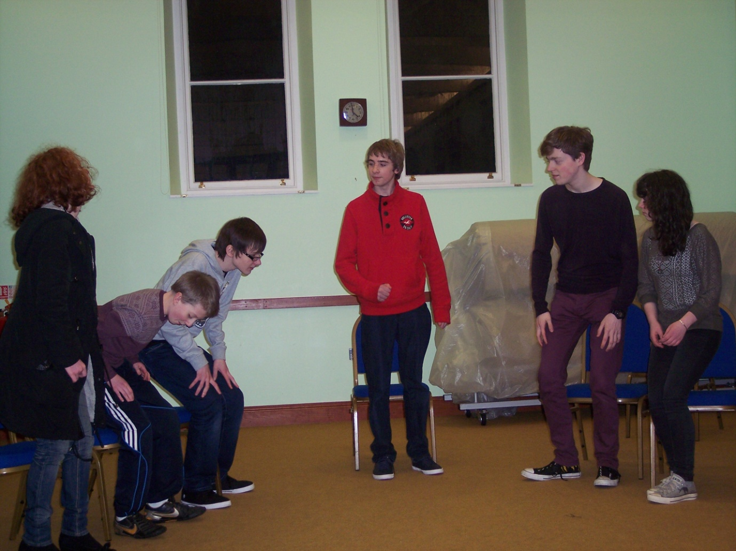
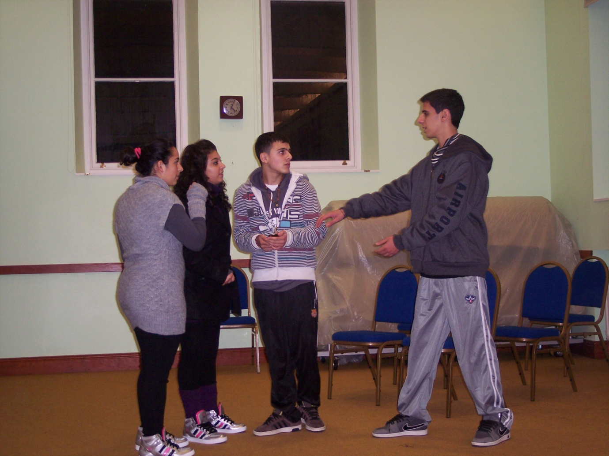

Developments in India: India’s Daughters
The young women from Lucknow who attended the 2010 Congress made a profound impact on the participants with their dignity, charm and courage. Urvashi Sahni, the founder and Director of the award winning Study Hall Education Foundation (SHEF), is their Indra co-ordinator. On the SHEF web-site Urvashi writes:
‘The unspeakable horror of the brutal gang rape and murder of a 23-year-old girl in the capital of the world’s largest democracy, India, on December 16th 2012 brought to the forefront the cruel, fatal, highly discriminatory gender norms prevalent in a country that now claims to be one of the worlds rising economic stars. A window has opened for responses that challenge these gender norms through critical dialogues and empowering education.
Along with the strong measures that the government should take to ensure the safety of our women, as a long term measure we should be working at educating our young people towards more equitable gendered perceptions. Everyone is clamoring for a change of gendered mindsets and I add my voice to the uproar – we should include gender studies in the post-primary curricula of all schools for both boys and girls. This is one way of ensuring that future generations of men will grow up respecting women and their right to bodily and sexual integrity. If it is important to give our children an understanding of maths and science, it is equally important for them to understand equality of gender. Educators have an important role to play in creating a safer, more just world for girls and women.
Studyhall Educational Foundation is launching a campaign called “India’s daughters: Unwanted, Unsafe, Unequal”. I invite the entire Studyhall family, students, alumni, teachers and parents to join us as we raise our voice and consciousness against gender violence and gender inequality in India in particular and in the world in general. The campaign will include online and offline activites which will be announced on our website. Please participate in the discussions by writing blogs and comments and encourage your family and friends to do the same. Let us all work together towards an egalitarian social order.’
As part of this campaign, SHEF will work in collaboration with the Indra Congress to use the power of theatre and the creative arts to help get this message across to young people, their families, teachers and the wider public.
We are proposing to adapt the Cooling Conflict framework and idea to specifically address the issues arising from the India’s Daughters initiative. This will initially be implemented in the schools and communities that make up the Study Hall Network, and then beyond.
(Again, if any of the Friends of Indra can point us in the direction of potential funding sources for this project do please let me or Urvashi know. We can set the project up and running for under £3000.)
Sierra Leone
Following the death of Samuel Johnson, our co-ordinator in Sierra Leone, Milton Margai College has appointed Dr D.S. Kai-Rogers to move Indra forward in Sierra Leone. Dr Kai-Rogers is Deputy Registrar at Milton Margai and we look forward to collaborating with him and other colleagues both at the College and in the wider community.
Plymouth
The Arts Council and local schools funded Cooling Conflict project in Plymouth inner city schools is proceeding well. We have conducted a series of day-long workshops in these schools, which have culminated with presentations to younger classes and demonstration sessions with parents. We held a training session for interested arts practitioners and in the summer and autumn we are looking forward to introducing a range of art forms, including puppetry and illustration into the process.
There is growing support from the University of Plymouth in the proposal to host Indra on the campus. There are mutual benefits in such a partnership ranging from providing a home for Indra to providing a network of international activities as a focus for research and student engagement.
In conclusion
There are potentially several strands to the activities and vision that makes up the Indra Congress. These range from grassroots projects, local initiatives, teaching and training projects to university based research programmes. However, the key thread is the live Indra Congress event that brings together young people, their co-ordinators, practitioners, academics and others in a face to face gathering every two to three years.
The live Congress event has the symbolic qualities of a Tibetan singing bowl. It is large enough to contain a multitude and diversity of individual vibrations that rise up with the unity of one clear sound. The Congress is also small enough to encourage and contain face to face conversations in a safe surrounding space.
We know that attending the Congress is a transformative experience for the young participants. That is why we are determined, despite the austerity of the times, to facilitate its happening. It is why we have taken the unprecedented step of asking the wider Friends of the Indra network for support and advice. So please make suggestions, point out possibilities or help in whatever way you can.

Many thanks
David Oddie
Tim Prentki
Dawn Melville

Indra Directors

Once upon a time the god Indra made a large net to cover the whole world. Each point of intersection consisted of a beautiful, precious pearl. None of the pearls existed by themselves except as a reflection of each other and of all the pearls in the net. In turn the whole net relied on each individual pearl for its existence.

The Old Woollen Mill, 77 West St, Tavistock PL198AQ
Tel: 01822 610801/07970033823
indracongress@hotmail.co.uk

The Indra Congress Community Interest Company (Reg No 7445371)

