Indra Newsletter 5 draft
The time is coming.............
Well, the Indra Global Congress in Derry 2013 is! We have just over a year now to prepare for this hugely important event in the emerging Indra calendar. Mary Duddy, Indra co-ordinator in Derry is working immensely hard to prepare the ground for the Congress. Thanks largely to Mary, the Congress has been recognised officially as part of the UK City of Culture programme in Derry. This puts us in a strong position to attract resources. However, we need to be working NOW to enable young people from the various hubs to attend.
For the 2010 event we raised considerable funds from a wide range of sources, such as the Bolton and Plymouth groups, Tavistock Quakers, students and staff at UCP Marjon and many others. We do not have the same infrastructural support this time and it will be a real challenge, for example, to get young women from Lucknow in India, young people from Sierra Leone or Palestine, to join us. I will shortly be getting in touch with each of the current, core groups to discuss where they are in their planning.
I was recently in a meeting with Alix Harris, who co-ordinates the Plymouth Voices for Change/Indra group. Alix was telling me about the high level of ‘chat’ that is still going in the realm of Facebook between the 2010 participants: a reminder of the profound impact that event had on the lives of participants.
Any advice, ideas or suggestions from the wider Indra membership regarding potential funding sources for the 2013 Congress would be gratefully received!
What will happen in Derry 2013?
Building on the success of the 2010 Congress we plan to undertake a programme of shared creative activities building up to the Global Congress event in Derry, 2013:

- young people and their co-ordinators in Indra hubs will undertake conflict related projects in their own communities and then share the process and experience virtually with their peers across the world

- the Congress will then provide an opportunity for the participants to come together and share their practice, ideas and experience

- there will be a wide range of workshop activities, training opportunities, sharing of performances, speakers, discussion groups and social activities, culminating in a shared celebration/performance event at the end of the week

- this activity will be complemented with an academic and practitioner based seminar to encourage dialogue with the wider world of practice and theory.
The build up to the Congress
Edge Hill University August 2012
The UK Indra hubs in Burnley, Bolton, Plymouth, Durham and Derry have raised the funds to hold a planning and training week in August to prepare and plan in detail for the 2013 Congress. This will take placed at Edge Hill University during the week of August 13th. We are grateful to Matt Jennings for initially arranging to host this gathering and, since Matt’s departure to Northumbria, other colleagues at the university who have endorsed this generous offer.
Other news
The Bolton group works within Activ8, the Community and Youth wing at the Octagon Theatre. Activ8’s INDRA group is made up of a mix of young people from across Bolton. The young people explore current issues and affairs that are happening in the world and investigate those issues using drama.
They have been very active and recently some of the participants took part in a trip to South Africa to help build a child development centre for the Kayonda Project in Lehae, South Africa.

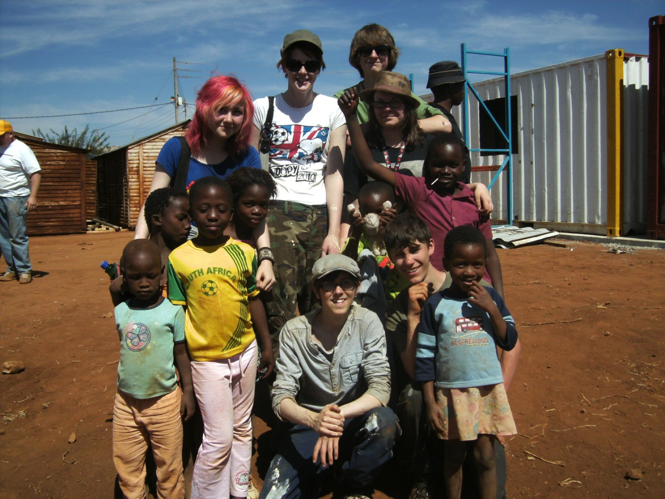
Moira Frew is a youth worker from ‘Halliwell Action for Working Alongside Youth’ (H.A.F.W.A.Y) – a project based in Halliwell, Bolton that provides a range of opportunities for children and young people aged 8 to 18 years. Moira works closely with activ8 and together they organised the trip to South Africa. Eight people from activ8’s INDRA group, along with 14 from H.A.F.W.A.Y, joined forces with more youth groups from across the UK, and travelled to South Africa to help build a crèche for orphaned children.
Moira went on this trip of a lifetime along with Hannah Middleton, facilitator for INDRA. Here they both share their account of what they got up to in South Africa...
Extract from Moira’s Musings:
We ground out windows and doors. Painted. Built window frames and door frames. Painted. Built a block wall. Put up partition walls. Installed toilets and cubicles. Painted. Found the mains sewer to join into. Put up security fencing. Moved the existing units from the old site to the new site. Painted again....
Personally the one moment that I will remember is while handing out goodie bags in the informal settlement we stepped into the ‘house’ of one family. This was a single room built from scrap material and corrugated steel. I asked the lady who lived with her and she told us that it was her and her two daughters aged 14 and 10 years. This was a single room which held a paraffin stove for cooking and heating, various shelves around the outer edge for storage and one bed. I asked the two young people that were with me if their bedrooms were bigger than this room/house. They, embarrassedly, admitted that they were.
Hannah’s account:
Once we got to South Africa and work commenced, I was expected to do just as much work as the young people, including mixing concrete in the midday sun and painting ceilings - as I was tall enough to reach them!
We also used power tools for grinding and cutting out windows and doors. There were foundations to be laid and welding to be done! It was extremely satisfying seeing a job completed and it wasn't all hard work. A lot of fun was had as well.
We went into a Non-Formal Settlement and saw families that lived on as little as £14.00 a month. It really opened all our eyes to the poverty in the country and the gulfs between rich and poor. Whilst there we gave out food and bags of clothing and everybody agreed that it was a deeply upsetting but worthwhile experience. On a happier note, on one of our last days we got to play with lion cubs, which was amazing as well!
The work of INDRA is extremely important to the young people who attend. It gives them a safe space to come and discuss ideas and share stories. The INDRA group consistently impresses me with their thought-provoking and insightful contributions to the sessions. INDRA aims to build up community regardless of location.

South Africa

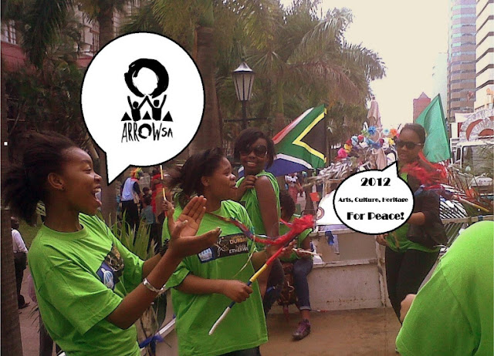

Who am I? Positive Hands and Feet

Extracts from notes by Luthando Ngema

The ARROWSA hub based at Bechet High School in Durban has had an exceptional start to the year of 2012. The programme this year was to be planned around the theme of “Who am I”. This theme was explored through using different parts of the body to define who we are as individuals and who we are as a group. In the spirit of the theme,we used different parts of our bodies to explore in- depth descriptions of who we are. The first activity that the group participated in was the hand mapping exercise (based on the concept of body mapping started with the Aids Society Research Unit in Cape Town). This was part of using hands as a source to display aspects of oneself in the palm, wrists and fingers of the hand.

Hand Maps were placed together against a black board, which made a good metaphor of the different hands coming together, forming one vision of unity. The hand exercises continued through Hand Games. The Hand Games are a fast paced sing and clap exercise, which requires two or more players to add to the fun. Through Hand Games we learnt that there are more similarities than differences within our diverse cultures.

After a presentation on why “Why is Dance an Important part of Society”, a dance craze then took over the event as we each performed popular dance moves that promotes our individuality. To further the knowledge of dance, we explored the Gumboot Dance as a dance form popularised during the apartheid regime in South Africa. The spirit of Gumboot dance embraced unity, solidarity and escape from the harsh realities that faced the mine workers. The dance is referred to as the Gumboot Dance because of the Wellington boots worn during the dance. This trend was taken from the mine workers in South Africa, who used wellington boots to protect their feet under the ground. It is a fast paced dance, which is rhythmical, percussive, with a great ‘stomp’ as the end result. At the end of the session, the group had formulated an excellent Gumboot dance piece, which worked around the theme of “Siyanqoba” which means, “We are winning”.

We look forward to also finding out ‘Who are you?’ through projects already initiated with Zimbabwe, Chile and the United States or with any other African or global communites who share the goal of Arts, Culture and Heritage for
Peace.

Research

I am delighted to share with you that the University of Plymouth has invited me (David!) to become Visiting Research Fellow in Applied Theatre and Drama in Education. I am looking forward to working with colleagues at Plymouth to develop a mutually beneficial dialogue between Indra and the university.

The Indra web-site

We have recently updated the website to reflect the continuing evolution of The Indra Congress as a Community Interest Company. In one of the sections we have listed our partners and we would like to link to our partner and friends websites, so if you could send though a link that would be great (please also send a short paragraph to summarise the site). There is also a news and events section so if you have any information you would like us to add to the site, please send it through to dawn@theindracongress.co.uk

With best wishes from

David Oddie
Dawn Melville
Tim Prentki

Indra Directors

Once upon a time the god Indra made a large net to cover the whole world. Each point of intersection consisted of a beautiful, precious pearl. None of the pearls existed by themselves except as a reflection of each other and of all the pearls in the net. In turn the whole net relied on each individual pearl for its existence.

