Indra Congress Newsletter 12 March 2015
Focus on India
Dear Friends of Indra
The Study Hall Education Foundation (SHEF), founded by Dr Urvashi Sahni, in Lucknow is Indra’s partner in India. David Oddie was invited by Urvashi to lead a two week drama training programme with staff and students of SHEF and others in the region. This newsletter is a series of extracts from David’s journal.
SHEF, under Urvashi’s guidance, is developing a model of educational practice that has profound implications for education in India and indeed beyond. Their emphasis on ‘life outcomes’, which go beyond traditional ‘learning outcomes’ provides an exemplar of practice from which much can be learned worldwide. The arts have a central role to play in the process.
David’s Indian journal 2015
In January 2015 I was Invited by our dear friend and colleague, Dr Urvashhi Sahni, to deliver a series of workshops in Lucknow for the Study Hall Foundation (SHEF). Urvashi also invited my wife, Hilary, to be her personal guest at her home in the city. Young people from SHEF had previously attended Congress events in Plymouth and Derry. They had made a significant impact with their warmth, dignity and courage. I felt honoured, excited and some trepidation at the prospect of working more systematically with their peers and teachers in India.
India is a vibrant and vast land, teeming with diverse people, full of contrast and contradiction. Since independence in 1947 so much has been achieved and yet millions are still trapped in abject poverty. Illiteracy and lack of educational opportunity are rife, especially for girls. The Study Hall Foundation was founded by Urvashi, who has dedicated her life to providing educational opportunities for disadvantaged young girls in Lucknow and beyond.
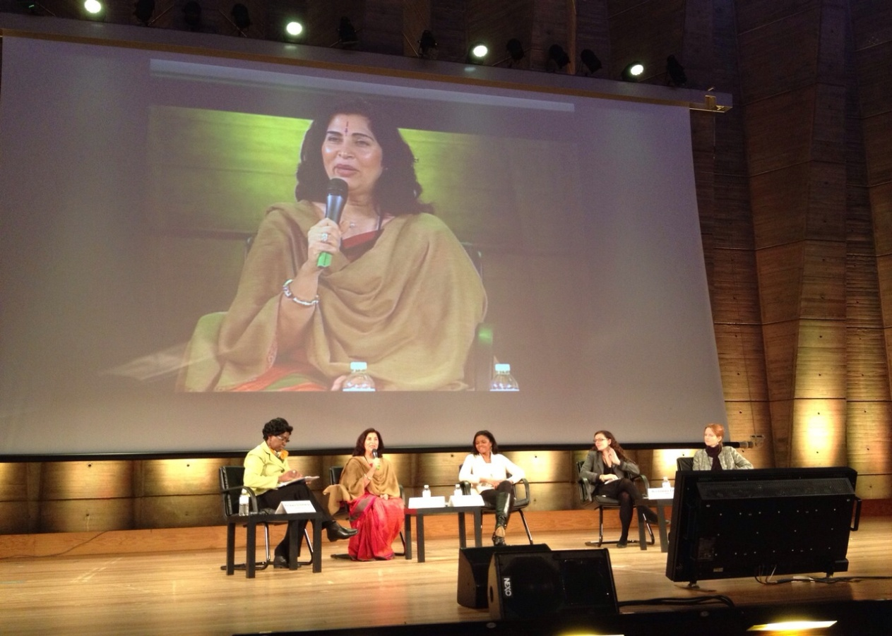
Urvashi speaking at a UNESCO Conference in Paris February 2015
Arrival
The noise, chaos and energy of Lucknow has an immediate impact. Driving in the city is a terrifying experience; it is difficult sometimes to know which side of the road traffic is coming from and red lights are simply ignored. Urvashi collected us from the airport and we were driven to her impressive and elegant apartment. Here we had our first taste of a ceaseless production line of wondrous curries and spiced dishes prepared by her skilful cook, Bina. Hilary and I were tired after the journey and needed to rest. Some chance! We arrived in Lucknow in late January, the final stages of the marriage season. There was a marriage function room nearby, which was in full flow with drums, musical instruments and vocals; presenting an avalanche of ear bending sound into our room. There was also a rail track nearby with a level crossing. Approaching trains hooted loudly and persistently to warn unwary pedestrians, cyclists and cattle that wandered over the track. Fortunately the weddings finished, by law, at 11.00 p.m, although the trains continued through the night. After a few days, we just got used to it and could get on with the job of sleeping.
SHEF
The following day, prior to beginning the workshops, I was shown around the various branches of the Foundation – and the more I learned the more impressed I became. Urvashi is indeed a remarkable woman who, despite pressures of family and a range of social constraints, has committed herself to the education of disadvantaged young people. The more extraordinary part of this story is that, not only has Urvashi provided the facilities for a basic education, she knows that girls, and indeed India, need more than that. They need an education that gives them a sense of self worth, confidence, creativity and dignity. Urvashi has evolved an educational vision that goes beyond training for a job. To this end Urvashi has employed the arts as an important part of the curriculum. Engaging with the arts provides a platform for young people to share stories, to laugh, to cry and celebrate their humanity, and to challenge the contradictions, injustices and inequalities experienced in their daily lives.
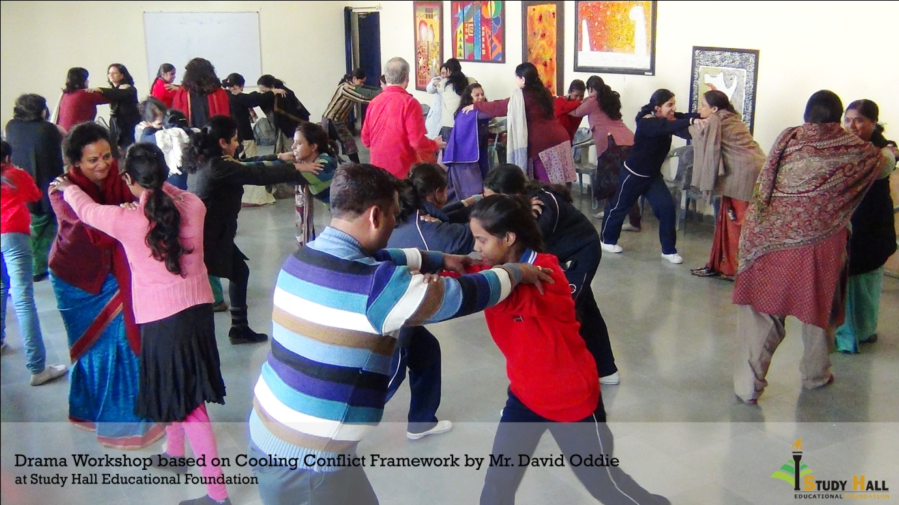
Summary of Study Hall structure and activities
By day Study Hall is a flourishing, fee paying school for around 1500 middle class children. School finishes at 2.30 p.m. At 3.00 p.m. the same building and resources become the base for Prerna School, which provides a high quality, virtually free education for disadvantaged girls who are vulnerable to poverty and abuse and suffer every prejudice in the book from gender to caste: ‘The girls come from the neighbouring slums and communities and, being compelled by their circumstances, most of them work in houses as domestic helpers’.

As Urvashi writes:

‘Prerna’s main goal is to empower its students. To help them emerge as women with a perception of themselves as equal persons having the right to equal participation in an unequal society, and to be equipped with the appropriate skills for such equal participation’. To this end:

- They must learn to read, write and successfully complete the government-mandated syllabus up to grade 12.

- They must learn to perceive themselves as equal persons.

- They must emerge with aspirations for a future for themselves, have the confidence and the skills to realize it.

- They must have a critical understanding of the social and political structures which frame their life and determine its limits and possibilities.

More recently, Prerna Boys School has also been developed as a school for underprivileged boys form very poor economic backgrounds.

Digital Study Hall, started in 2005, is a research project that seeks to improve education for poor children in slums and rural schools throughout India. They produce a series of video and digital teaching resources that are made widely available to isolated teachers who lack resources and training opportunities.

Vidyasthali Kannar School is a linked rural co-educational school, situated in Malihabad, 32 kilometres from Lucknow, which offers education opportunities to over 370 boys and girls, coming from 44 villages.

The Prep School of Study Hall offers a distinct and systematic source of education to children from the ages of three to five. In addition, Dosti, an integrated programme for children with special needs, provides education to over 70 physically and mentally challenged children. In 2013 the Centre for Learning was initiated with the aim of helping children with learning difficulties, special educational needs and slow learners.

Prerna is linked closely with the economic enterprise of Didi’s, which was initiated through Sisters in Solidarity (SIS). This is an autonomous society which runs 2 units under its umbrella, Didi’s Foods and Didi’s Creations. Didi’s Foods provides unique opportunities for Prerna girls and their families through training in cookery, bakery, food processing and packaging. Didi’s Creations imparts training in cutting and tailoring, embroidery, and customer service. Products created by the women are sold in the local markets.
Urvashi is committed to spreading her ideas more widely, e.g. to government schools and teacher training institutions. As a globally celebrated educator, Urvashi is increasingly invited to advise at regional and government levels and is in much demand at international conferences and symposia.
The drama workshops
The workshop programme would include:
5 half day, intensive sessions with a mixed group of 40 teachers and students from SHEF units.
A 2 day course for a 50 strong mixed group of children and staff from a Lucknow KGBV (Kasturba Gandhi Balika Vidyalaya) school. The KGBV scheme was introduced by the Government of India in August 2004, ‘to ensure access and quality education to the girls of disadvantaged groups of society by setting up residential schools with boarding facilities at elementary level’.
2 whole day courses with students from two teacher training institutions, one rural and one city based.
Urvashi and I discussed the aims of the workshops:
- to build on existing understandings of the nature of drama and its applicability to the teaching, learning and social priorities of SHEF
- to provide a creative, safe space in which participants could share stories and experience, reflect on implications and explore strategies for dealing with challenging issues arising
- to give participants a really enjoyable and memorable time!
Urvashi and I discussed a structure for the sessions and decided I would include a range of practical, introductory exercises illustrating the core values of using drama in education. I would then adapt the Cooling Conflict framework of John O’Toole and colleagues as a detailed example of a process drama. Cooling Conflict provides a useful model of practice, which starts from the experiences of participants, then develops collective narratives, which integrate personal experience into a fictional, imagined context. Using Enhanced Forum Theatre (EFT), with accompanying process drama techniques such as hot seating and freeze framing, teachers and learners together could then interrogate these situations and explore alternative, personal and collective strategies for responding to and working with the issues.
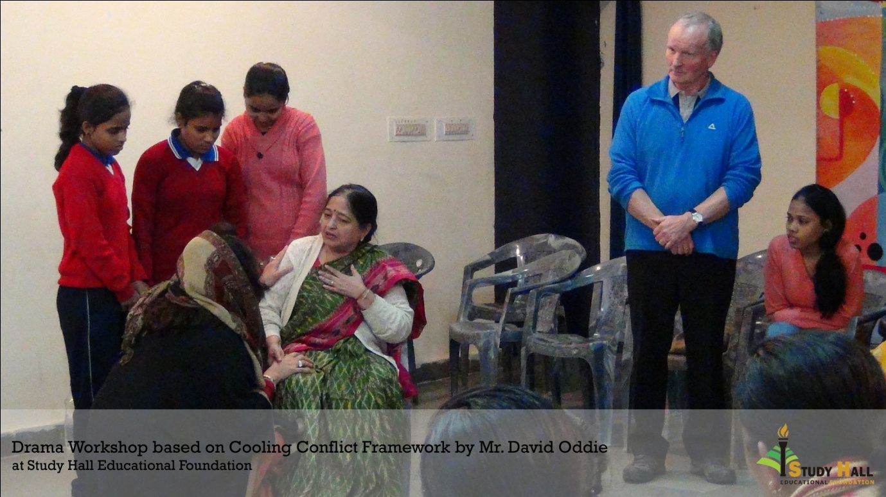
Some reflections
My first set of workshops were with a mixed group of teachers and students from different SHEF sections. The workshops were to be conducted in English, although Urvashi was present throughout most of the sessions as interpreter. I was delighted by the warm and enthusiastic response of the participants. They were willing to ‘play’, which is an essential starting point. I have taken so many workshops sessions in the UK where the first major challenge is to release participants from their fear of playing, to create an atmosphere of trust and playfulness. This willingness was all the more impressive when the group consisted of the executive head of SHEF, headteachers of various sections, teaching staff and students from both Study Hall School and Prerna. There was a perceptible feeling of community, of family; learners and teachers working, sharing and learning together.
This openness, coupled with an intrinsic awareness that play provides a crucial vehicle for understanding and addressing profoundly serious questions, made my job as facilitator so much easier and, in turn, draw out my own passion for drama both in and as education.
The participants took on board the introductory exercises, from various group games, an understanding of the basic needs and core skills to engage with the medium and a range of image theatre activities.
Urvashi’s aspiration for SHEF is based on a vision of education that goes well beyond the basic requirements of literacy and numeracy. Urvashi knows that young girls attending Prerna may be dealing with severe emotional and social pressures. These may range from discrimination and abuse to sometimes violent resistance to girls’ education from within the family. High drop-out rates in the early stages of Prerna highlighted the need to prioritise the girls’ well being if they were going to progress and succeed with their education: ‘Of course they were all poor, but many of them were at risk of being married off soon after reaching puberty and domestic violence and sexual abuse were rife in their homes. Many of them worked as domestic helps, starting as early as the age of seven. The girls all worked hard at home and started looking after their younger siblings very early, sometimes as early as three years’.
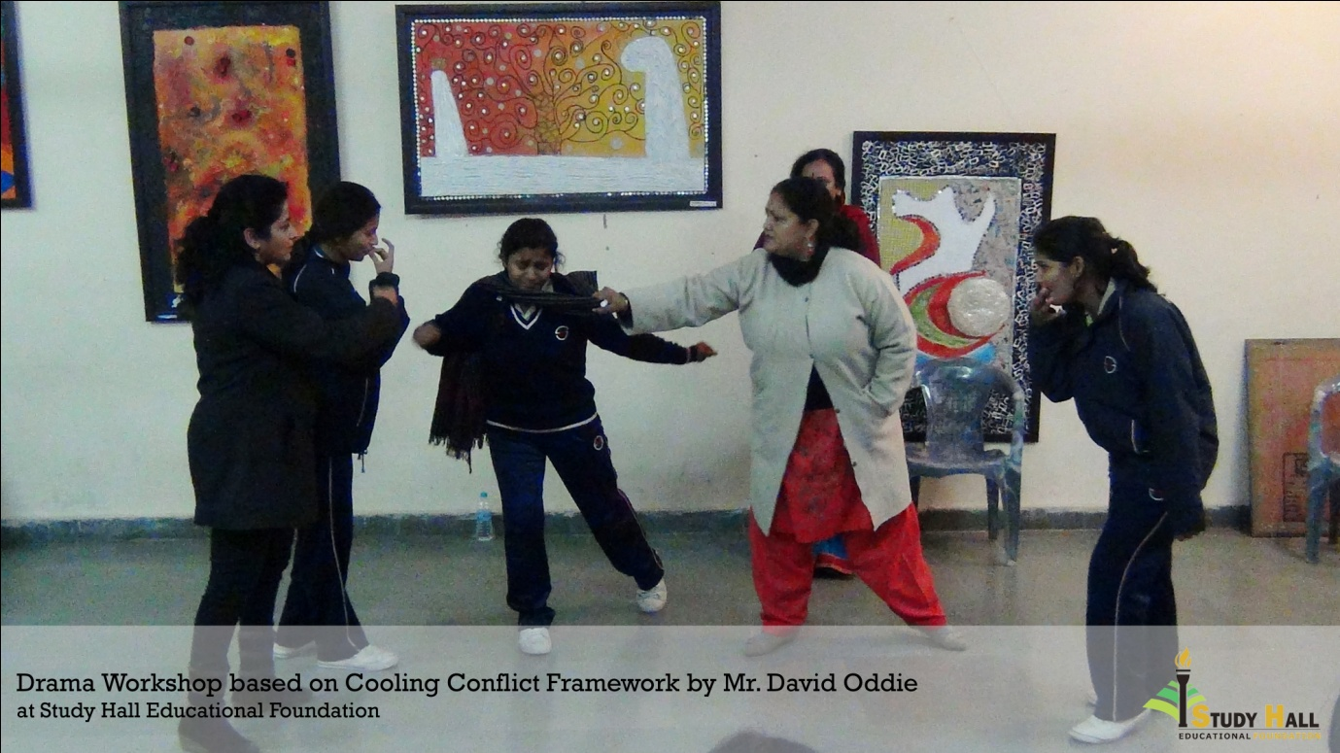
The school shifted its policy from thinking about ‘learning outcomes’ to thinking about ‘life outcomes.’ As Urvashi writes:
‘So Prerna moved toward a truly transformative education which had the aim of raising girls’ expectations and consciousness, enabling them to engage in critical and creative thought, to describe their reality, critically examine it, learn to imagine the possible, aspire to make it real, develop a voice in which to criticise, debate, inquire, resist, negotiate and to struggle to achieve transformation and equity.’
Urvashi saw the practice of arts education as being central to the girls’ understanding of the contradictions and inequalities in their lives: drama providing an appropriate vehicle through which the aspirations of ‘critical dialogue’ can be achieved. Through the devising process of Cooling Conflict, core issues of gender inequality, such as the expectation for girls to work at home rather than go to school, and to marry at an early age were given powerful expression. Dealing with powerful in-law authority figures, the impact of caste, alcoholism and poverty on families also arose consistently. Enhanced Forum Theatre provided a vehicle for participants to share these experiences, with which they were already familiar, but also to explore and discuss strategies and seek wider alliances. Sharing such experiences is important for solidarity and mutual support, but we also debated how to move further and engage family, community, political and other agencies in the process.
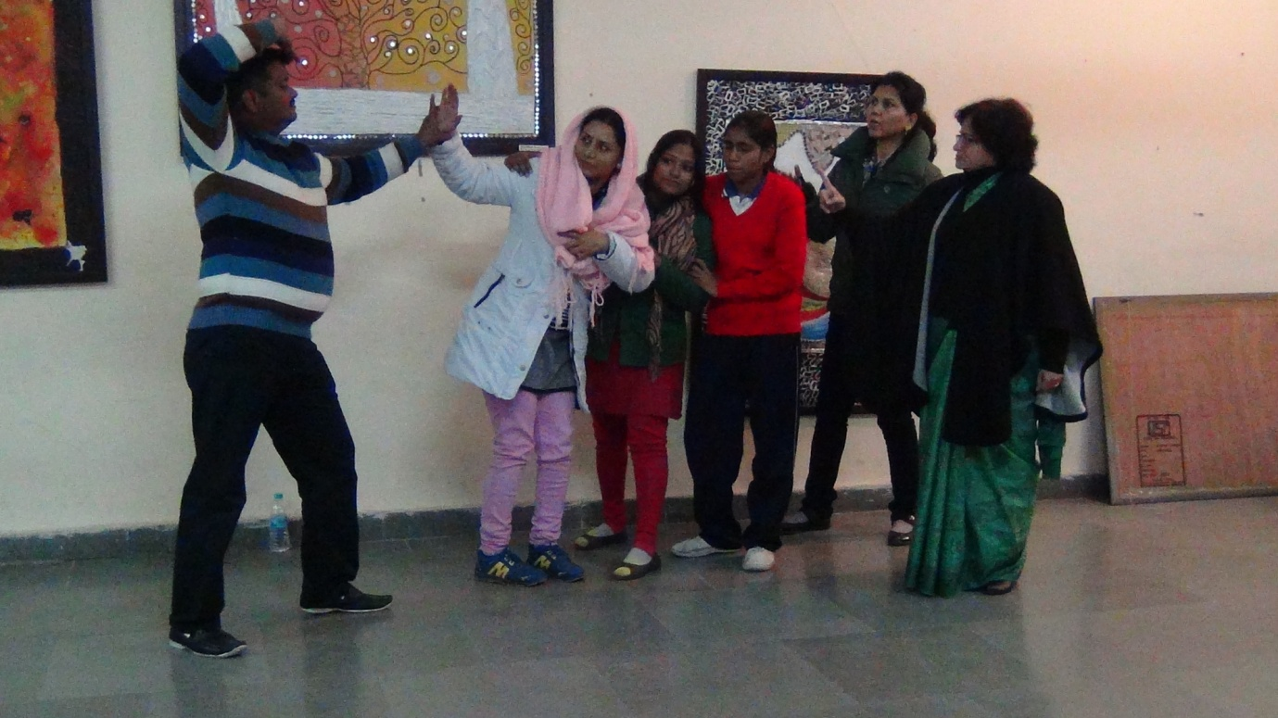
It was agreed that I would write up a hand book covering the range of approaches and techniques we had been using throughout the workshops, which would be translated into Hindi and hopefully used more widely within SHEF and beyond.
We also discussed the viability of engaging Digital Study Hall to re-design the Indra Congress web-site and operate it from Lucknow.
It was a joy for me to meet with the young women who had attended ARROW/Indra Congress events. Urvashhi invited Kushboo, Kunti, Laxmi, Soni and Sunita to join us at her house for tea one day and we had a had a lively catch up session. We also visited the village school of Vidyasthali, where Sonam, who was one of the two girls granted visas for the Derry Congress, invited us to her home to meet her mother. In the village we also met,Preeti Yadov, who was one of the young women who were denied visas by the British High Commission to attend the Derry Congress in 2013. Happily the funds raised for Preeti’s travel could be used for her to participate the following year in the South Africa and India exchange programme.
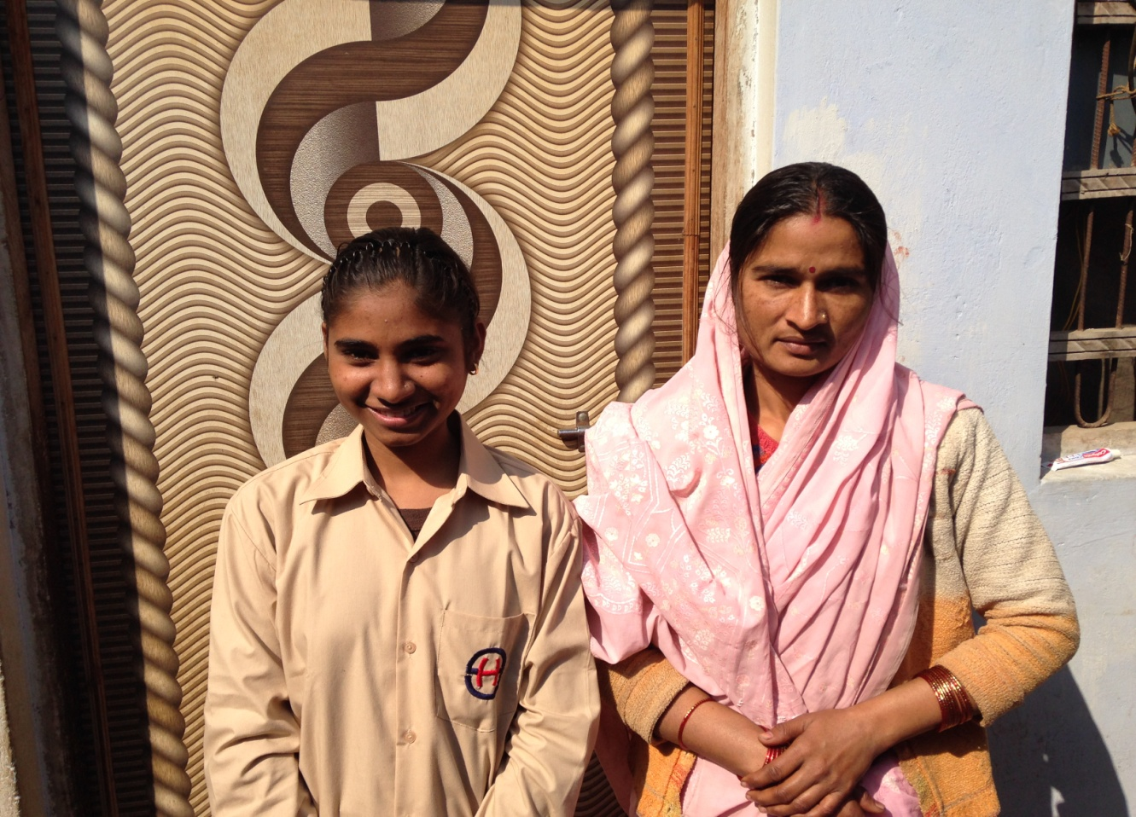
Sonam with her mother outside their home
The partners in the Indra Congress continue to weave Indra’s Net as a source of creativity, compassion and hope.

