The Indra Congress Newsletter 11
First of all, a happy new year to you and let’s hope 2015 sees some movement towards a world more at ease with itself.
Plymouth Congress 2015
Following the successful Derry Congress in 2013, our dear friend Marina Barham of Al Harah Theatre invited us to hold the 2015 Congress in Bethlehem. Recent events in Gaza made this aspiration unrealistic and we have postponed the event until 2016. We were all deeply moved by crises affecting Indra partners through war in Palestine and Ebola in West Africa. We therefore decided to hold an interim Congress event in Plymouth, to rise to the challenge of how Indra partners could still work creatively and interactively with their isolated colleagues across boundaries of geography, language and culture to create original drama, dance and art work together.
The Plymouth Congress would also enable us to plan in detail the following Congress events in Bethlehem (2016) and Durban, South Africa (2017).
What we propose to do
Title: What’s it got to do with me?
Our aim is to create a ‘live’ and virtual space in which young people across the global Indra network can devise a simultaneous and innovative theatre, dance and arts event. The ‘live’ event will take place in Plymouth during the week of the 5th July and, using digital technology, directly engage Indra participants in Sierra Leone and in Palestine.
In the build up to the Congress, Indra groups will exchange personal and cultural images, metaphors and ideas through social media. Participants who are able to travel will gather at the House Theatre, Plymouth University. They will share experiences through performance and collaborate with professional artists to create a space in which they can work together creatively and interact virtually with their isolated peers - and Indra participants unable to attend ‘live.’
At the end of the week artists and young people will draw the project strands together to create an innovative dance theatre event, involving both face to face ‘live’ participation, and virtual engagement with their isolated and absent peers. This will be in the form of a public performance at the House Theatre.
We aim to provide a model of practice through which young people work with artists to create meaningful, ‘live’ art across boundaries of space; give expression to their shared humanity and ‘plural’ identities and acquire the confidence, arts and digital skills to further become creative, cultural leaders in their own settings.

Appeal!
The Plymouth Congress is being put together at rather short notice. It has therefore been a struggle to assemble the resources to get numbers of young people from around the world to Plymouth, provide accommodation, food and the artistic resources needed for this challenging and ambitious project. The Paul Hamlyn Foundation has made a generous contribution and we are very grateful to colleagues at the University of Plymouth, who have offered us the free use of their brand new theatre and studio space, The House.
We would be very grateful for any direct contributions, however modest, or further funding suggestions to help us make the Congress an inspirational event in the lives of the participants - ‘live’ and virtual.
Symposium: What’s it got to do with HE?
Running alongside the Congress there will be a symposium which will, using the Indra Congress as a live reference point, explore the responsibilities of higher education to link with and support grassroots, community arts work of this nature. There will be a focus on the mechanisms through which academics, young people and artists can work together to create a significant programme of related research. There is an urgent need for evidence based research to ‘push in the faces’ of those who have influence and walk the corridors of power.
Widening the net
During the Congress we will explore the concept of a simultaneous dance taking place in Indra hubs around the world, which will enable us to reach out and engage new participants and audiences. We are often asked by individuals, groups and schools, ‘how can we be involved in Indra?’ The project presents an opportunity to explore this important challenge: we welcome new ways of widening the net, but at the same time it is important to maintain the personal, intimate nature of the network, which is an important part of its identity and usefulness.
PhD studentship University of Plymouth
For their 2015/16 doctoral studentship competition, Plymouth University is innviting applications to undertake practice-led research in digital arts, design, media and performance. The studentship would be located in one of the established four research units at Plymouth or, aligned with one of the University partners. The Indra Congress is identified as one of these partners.
Any successful students would have to be based in the Theatre & Performance research group and would have to propose practice-led research that involves digital technology. They would also have a second supervisor in i-DAT (the Insitute of Digital Art and Technology) and a third supervisor from Indra.
For further information please contact: roberta.mock@plymouth.ac.uk
Details can be found on the university web-site at: http://3d3research.co.uk/information/plymouth-university/
This presents an exciting opportunity for any potential PhD students with an interest in Indra, and a very important opportunity for Indra to be involved in important research.
Sierra Leone
We have all been deeply affected by the horrors of Ebola in West Africa. Two young people, Alfred Thullah and Ndeamoh Mansaray, from the group that attended the 2010 Congress have been communicating with us. Alfred has been in the quarantined town of Makeni for several weeks, whilst Ndeamoh is in Freetown. They both say how much they appreciate any communication from outside and describe movingly the anxiety and uncertainty facing them at this moment. These two remarkable young people are determined to maintain contact with the Indra network. They are seeking to build up an Indra group again in the country, which is motivated from the grassroots, rather than being set up by an NGO or similar body. When they have managed this we will do what we can to link them with such an organisation, so that they can apply for funding and support more readily. Please contact me if you think you could offer any help to these two courageous young people and their colleagues.
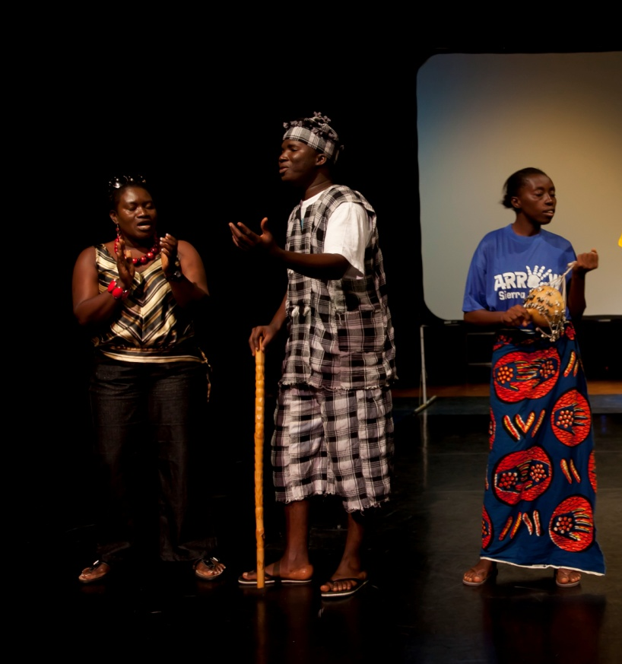
Above picture of Isatta, Ndeamoh and Alfred at 2010 Congress
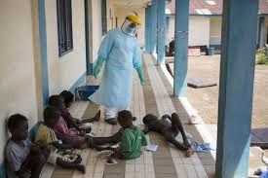
The nightmare of Ebola in Sierra Leone
Serbia
Paul Murray is director of the BelTheatre, the English Language Theatre in Belgrade, Serbia, a theatre company 'for and by' young people where all of the workshops, rehearsals and performances take place in English. Paul has expressed interest in joining with Indra and having a dedicated group engaging in Indra activities. We look forward to welcoming Paul to work with us and hope to see him, and possibly some young people from Belgrade at the Plymouth Congress. Participants in BelTheatre have just undertaken a 12 hour improv-a-thon to raise money for their forthcoming production of A Midsummer Night’s Dream.
Burnley
We would also like to extend a wam welcome to Lizzy Davis, who has recently joined Burnley Youth Theatre and is taking on the running of the Indra group. Lizzy recently graduated from Lancaster university and is keen to put her skills to the task of creating a new piece of work for the 2015 Indra Congress.
Publications
There are two forthcoming publications from the Indra writing stable this year!
Applied Theatre: Development by Tim Prentki. Published by Bloomsbury Methuen Drama on 26th February 2015.
Described as both guide book and provocation, the book addresses key aspects of what is termed Theatre for Development, i.e. principles, origins, politics and aesthetics in a concise and accessible style designed to appeal both to those new to the field and to experienced practitioners and academics.
A Journey of Art and Conflict: Weaving Indra’s Net by David Oddie. Published by Intellect July 2015.
The story of how a professional practice in the field of applied drama has emerged from the tensions, aspirations and thread of a specific life. The core chapters in the book tell the story of the founding and development of ARROW/Indra and the remarkable people encountered on that journey.
Tim has also written a short piece , ‘Banking on Drama Education’ (Drama Australia Monograph No. 7, September 2014) which may be of interest to those who teach young people in formal and non-formal contexts.
Reflections
For many people around the world 2014 was a brutal, cruel year. The war in Gaza devastated the lives of men, women and children in that tortured, narrow strip of land. In Syria the horrendous suffering of families and communities continues unabated. The emergence of a blind fundamentalism in the Middle East has brought fear and despair to thousands of people trapped in its relentless path. The nightmare of Ebola has struck without mercy the lives of innocent, already struggling people in West Africa. We have seen obscene disparities of wealth and the appearance of food banks in the UK, as austerity bites deeper into the lives of vulnerable people. And so it goes on....
It is tempting to give way to despair, to blame religion or, as we have increasingly seen in the UK and Europe, to blame ‘the other’. Liberal minded folk in the west may suffer guilt because ‘it’s all our fault, we drew the boundaries, we take the oil and ravage the planet, we sell the arms.’ The Indra Congress is an attempt to reach out and listen to the voices of young people around the world who, despite the odds, persist in seeking and demanding a better, more compassionate world. Our modest gift is to provide a network, Indra’s net, that encourages them to use the unique language of the arts to see ‘the self in the other and the other in the self.’
This is why the theme of the Plymouth Congress is ‘What’s it got to do with me - and what can I do about it?’ This is born of an unashamed idealism, not a head in the clouds flight of fancy, but a hard headed acceptance of the fact that listening to the stories of others, talking, communicating, sharing, challenging and building authentic and equal relationships is a profoundly important part of the process of change: it is something we can all do, and the language of the arts is a unique and powerful way of doing it..

