NEWSLETTER 10
Dear Friends of Indra
Following the successful Congress in Derry 2013, Indra co-ordinators accepted an invitation by Marina Barham, Director of Al Harah Theatre to hold the 2015 Indra Global Congress for 2015 in Bethlehem. The recent traumatic events in Gaza, which have had immediate repercussions in the West Bank, have caused us to review our plans. We are currently discussing a range of options. The scale and horror of the ruthless bombing of Gaza, with the accompanying huge loss of innocent life, has awakened many people to the realities faced by Palestinian people through the ongoing, calculated occupation of the West Bank and the virtual imprisonment of people, through the siege and blockade, in the densely populated Gaza strip. There is now a growing groundswell of public awareness and opinion that is demanding international action to end this unacceptable situation.
Marina Barham has sent us a statement from Palestinian arts organisations, which is calling on artists and cultural organisations to support the academic and cultural boycott of Israel (PACBI). I was recently in South Africa where the Israeli historian Ilan Pappe, author of The Ethnic Cleansing of Palestine, was endorsing this call. The request for support was also endorsed by Desmond Tutu, a major inspiration and guide for the ARROW/Indra programme since its inception. Here is the Artists’ statement:
Statement by Palestinian Arts organisations
"Your voices are heard"
We, organizations and individuals that make up the majority of the Palestinian cultural sector; musicians, circus artists, actors, dancers, poets, filmmakers, photographers, authors, sculptors, painters etc., call upon our fellow cultural workers around the world to condemn and act against Israel’s assault on Gaza.
Despite all the hardships, the Palestinian arts and cultural institutions continue to work in Gaza, using the arts to comprehend, process, educate and mobilize. We stand with them and we ask you to do the same.
Is it wrong for one human being to voice concern over the suffering of another? Is it wrong to condemn the killing of thousands of innocent women, men and children? Is it wrong to denounce the destruction of schools, hospitals and places of worship?
You and I know the answer to all these questions!
Unfortunately, in the midst of the current destruction, killing and unimaginable suffering - the voices of Gaza are unheard. These voices have continued to call upon the international community, but to no avail.
Therefore we are so grateful for your courage.
If death and destruction continue in Gaza and no voices of condemnation are heard, one would wonder if we were still human.
Therefore we are so grateful for your humanity.
We, members of the Palestinian arts and cultural sector would like to extend our deepest gratitude to you for speaking up against the assault in Gaza.
Let us unite our voices for freedom, hope and a better future for the children of Palestine.
We call upon our fellow artists and cultural organizations to condemn the current aggression against Gaza as well as the illegal occupation of Palestine. Further to that, we urge you to act by supporting the Palestinian academic and cultural boycott of Israel (PACBI), thereby refusing to be complicit in the ongoing occupation.
- Please endorse the academic and cultural boycott of Israel (see http://www.usacbi.org/pacbi-faqs/ or http://www.pacbi.org)

- Please share your statement or action with us by e-mailing Rula Rezeq <rula@qattanfoundation.org>

- Tweet using #FreePalestine

Representative organizations in the Palestinian performing arts community who have endorsed this call:
Al-Harah Theatre, Bethlehem: www.alharah.org

The Magnificat Association, Jerusalem: www.magnificat.custodia.org

The Edward Said National Conservatory of Music, Ramallah and Gaza: http://ncm.birzeit.edu/en

Al Kamandjati Association, Ramallah: www.alkamandjati.com

Theatre Day Productions, Gaza: www.theatreday.org

Yes Theatre, Hebron: www.yestheatre.org

The Palestinian Circus School, Ramallah: www.palcircus.ps

The Freedom Theatre, Jenin refugee camp: www.thefreedomtheatre.org

Popular Art Center, El Bireh: www.popularartcentre.org

El Funoun Dance Troupe, El Bireh: www.el-funoun.org

Ashtar Theatre, Ramallah: www.ashtar-theatre.org

A.M Qattan Foundation, Ramallah and Gaza: www.qattanfoundation.org/en

Al-Rowwad Theatre, Aida Refugee Camp: www.alrowwad.org

Other News
South Africa August 2014: Summary thoughts from David’s journal
I have been a keen observer of events in South Africa over several decades, although I have never, until now, visited the country. Mary Lange generously offered to put this right and invited me to travel to South Africa and work with the ARROWSA young people, learners from Bechet School where the ARROWSA INDRA project of the NPO is based, University of KwaZulu-Natal university students, University of South Africa lecturers, teachers and to speak briefly at a couple of events. We would also have meetings with civic officers to discuss and plan for the Indra Congress for 2017 in Durban.
During the visit I was very mindful of how events and key figures in South Africa had been the source of inspiration for the original Arrow/Indra initiative: especially the passion for justice tempered with the wisdom of reconciliation as expressed by Nelson Mandela and Archbishop Desmond Tutu. South Africa has a complex history with diverse narratives and traditions interweaving and clashing. The profound impact of the apartheid era on the psyches of all South Africans cannot be transformed over night, it will take generations. There are many people of good faith, courage and determination committed to the journey: Mary Lange, her family and colleagues are amongst them.
During my stay, besides working with learners from Bechet School and the wonderful ARROWSA group based there, I worked with students from the University of KwaZulu-Natal and discussed collaborative research possibilities with lecturers. Most challenging of all, I was asked to induct a group of 40 teachers into the Cooling Conflict framework. The teachers came from diverse schools ranging from exclusive and predominantly white staffed institutions, to teachers working in township settings. As one of the participants noted at the end, ‘you had the whole of South Africa in this space today!’
One of the highlights of the visit was watching the play Imbewu Yesizwe II, performed by the ensemble cast of ARROWSA Bechet INDRA under the imaginative direction of Bhekithemba Dlamini to a large community audience. The performance had a vibrant, riveting energy.
The narrative thread was a disturbing story of abuse, punctuated by music, poetry, dance and choral singing. There was a tongue in cheek hint of melodrama, often on the edge of going too far, which had the capacity audience laughing, crying and singing: no passive audience this! They nearly brought the house down with their response – literally, for the ceiling in the Bechet hall has a worrying bend!
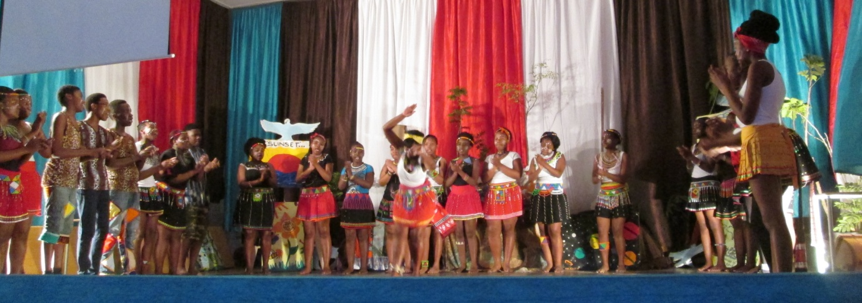
The opening chorus of Imbewu Yesizwe II.
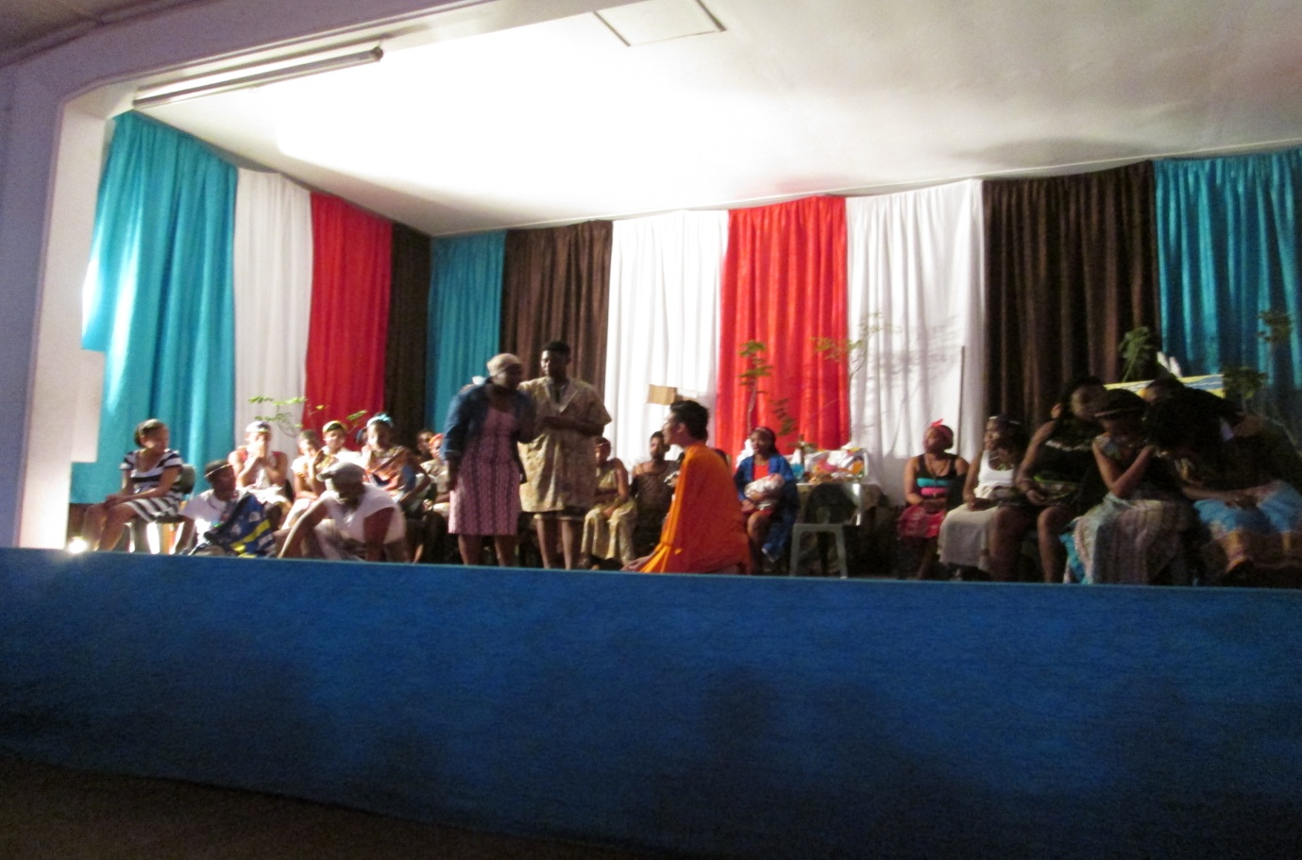
The final scene from the play; in a wonderful moment of dramatic irony, just at the emotional climax of reconciliation, a member of the congregation will fall of her pew in a drunken stupor.
Mary introduced me to the Palmiet Nature Reserve riverside archaeological dig near to the lodge where I stayed. Mary’s research in archaeological sites in Durban, the Kalahari and her work with the Bergtheil Museum are an important part of the wider ARROWSA programme. Such research helps to endorse the country’s unique history and the deep rooted origins of its diverse peoples and cultures.
Just prior to my own visit there was an exchange programme involving young people from ARROWSA going to Lucknow, India to visit their Indra peers at Urvashi Sahni’s Study Hall Foundation and vice versa. I hope to pass on further information about this in a further newsletter.
I am very grateful to Mary and her colleagues for organising my visit, during which I have learned so much about this remarkable country.
Sierra Leone
The outbreak of ebola in West Africa is a deep cause of concern. We extend our thoughts at this time to our colleague Isatta Kallon for whom this is a worrying time: contact and communication with friends and family in the country are not easy at the best of times. Some of you may recall the ARROW 2010 Congress to which Alfred Thullah and Ndeamoh Mansaray contributed so warmly. We hope they remain safe and well.

David Oddie

